Lessons Learned From France’s Shift Toward Accounting for Climate Change Factors in Environmental Assessments

Abstract

For many years, environmental assessments have included climate factors through the use of average weather data, but without using an approach that accounts for climate change factors.
However, as the field of study grew in the 2000s, climate change factors began to be accounted for through greenhouse gas emission assessments and sanitary surveys (initial state, during construction, and during the operational phase) according to standardized regulatory methodology. Since August 2016, climate change has become a separate section of environmental assessments and must be treated as such with regard to two aspects: the project’s impact on climate change and the project’s sensitivity to climate change.

Keywords:
climate change, France, project, environmental assessment, environmental impact assessment

1 - Climate Factors in Twentieth Century Environmental Assessments
Since 1976, when the first regulation for carrying out environmental assessments (environmental impact assessments) in France was implemented, climate factors have been presented as historical weather data in France's environmental assessments:
- Temperature averages in recent years
- Precipitation averages
- Wind rose
- Data on local weather events: fog, hail, thunderstorms and snowfall.

Average Temperatures in °C
 | J | F | M | A | M | J | J | A | S | O | N | D | Year
High | 7.6 | 9.2 | 13.1 | 15.7 | 19.9 | 23.4 | 26.5 | 26.1 | 22.3 | 17.6 | 11.3 | 8 | 16.8
Average | 3.7 | 4.8 | 7.9 | 10.2 | 14.3 | 17.6 | 20.3 | 19.9 | 16.5 | 12.8 | 7.3 | 4.4 | 11.7
Low | -0.1 | 0.3 | 2.7 | 4.7 | 8.7 | 11.9 | 14 | 13.7 | 10.6 | 7.9 | 3.3 | 0.8 | 6.6
Table 1: Example of average monthly temperature data [3]

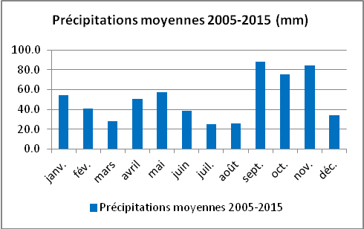
Figure 1: Example of how average monthly precipitation is taken into account [1]

Example of an initial state overview in an environmental assessment for a highway expansion project [3]:
“The climate of the study area is characterized by a wide temperature range each year. Summers are hot and stormy, while winters are cold and dry. Precipitation is moderate throughout the year.
The main weather hazard is a risk of severe thunderstorms in the summer. These storms lead to a rapid increase in river flow for certain rivers, significant freshet and flooding.
The climate of the study area is not a specific constraint for the project, apart from the thunderstorms and their consequences on the rivers, particularly those under construction. ”

2- “The fight against climate change is the top priority”
Over successive regulation changes, particularly since 2009, the climate has been increasingly present in environmental studies for projects (Section R.122-5 of the Code de l’Environnement [environment code]). It often pertains to greenhouse gas emissions, energy, health (inhalation, vector-borne diseases due to changes in microclimate), noise, environment, and natural hazards (extreme weather events).
The climate is considered with regard to several aspects:
- Assessment of the project’s compatibility with regional plans for climate, air, and energy, and with local plans for climate, energy, and land.
- Calculation of the social cost with regard to the greenhouse effect (for transport infrastructure projects).

The challenges of environmental assessment are as follows:
- Mitigating climate change, particularly by limiting greenhouse gas emissions;
- Adapting to the change in climate;
- Preserving the local microclimate;
- Preventing associated health risks;
- Preventing natural hazards.

However, analyzing the challenges and their effects and proposing reduction measures requires particular vigilance in certain areas:
- When calculating greenhouse gas emissions for the operational phase of a linear highway project over the medium and long term, it is necessary to account for alternative routes, limitation of the resulting traffic and the integration of technological changes.
- When calculating greenhouse gas emissions for the construction phase, a full assessment of the emissions caused by the construction must be carried out.
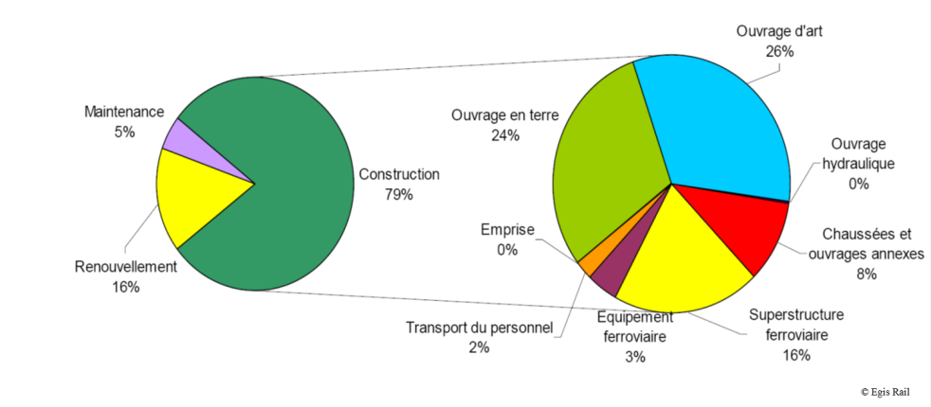
Figure 2: Example of a full assessment of greenhouse gas emissions during the construction of a high-speed rail line in an environmental assessment [2]

Adequate measures should thus be proposed, the use of construction procedures and materials with limited reliance on fossil energy should be promoted, and requirements for low greenhouse gas emissions should be implemented, particularly with regard to the material supply in tender enquiries.

- For microclimate studies, the project’s impact must be limited:
- Direct impacts: changes in sun exposure, changes in air movement and wind conditions, increases in temperature due to destruction of vegetation cover, pollutant dispersion, etc.
- Indirect impacts: dieback of species least adapted to new microclimate conditions, soil erosion/drying, environmental degradation, favourable conditions for developing diseases spread by carriers such as plant allergens (ragweed) and mosquitoes.
- These climate change impacts, particularly climatic extremes and weather hazards, must be accounted for by assessing natural hazards and direct and indirect impacts on the physical, natural (migration of species) and human environments.

3- Changes to regulations in 2016 and first lessons learned
Recently, accounting for climate change factors and the sensitivity of projects to climate change has gained importance and become a key aspect of environmental assessments in France. In fact, in August 2016, France ensured that its national law complied with European law (transposition of European Directive 2011/32/EU, amended by European Directive 2014/52/EU). This resulted in the publication of two new statutory texts (Order 2016-1058, which amends the regulations for the environmental assessment of projects, from August 3, 2016, and Decree 2016-1110, which amends the regulations for the environmental assessment of projects, plans, and programs, from August 11, 2016), which led to changes in sections related to the environmental assessment of projects in the Code de l’Environnement. These texts established the need for assessing and accounting for [translation] “significant impacts the project may have on the environment, resulting from: […] (f) impacts of the project on the climate and the project’s sensitivity to climate change […].”

In addition to the previously mentioned chapters on subjects such as greenhouse gas emissions and air quality, a chapter on environmental assessment must also be examined:
- First, how the project affects climate change;
- Second, the impact of climate change on the project.

Thus, environmental assessment now involves the project’s impact on climate change across several factors:
- The “global” climate, with its contribution to increasing or decreasing greenhouse gas emissions.
- The microclimate, by changing the weather conditions of a given area.

Example of part of a chapter about climate in an environmental impact assessment for a project to expand a highway to 2 x 3 lanes in the central region of France [3]:
Impact of the Project on Climate Change
The project to expand the A75 to 2 x 3 lanes between Clermont-Ferrand Est and Le Crest is not intended to increase traffic. One of its main objectives is to contribute to improving traffic flow south of Clermont-Ferrand. This section of the highway has heavy congestion during morning and evening rush hours.
The project thus has no significant impact on CO₂ emissions (greenhouse gases) for the area being studied.
Impact of the Project on the Microclimate
The changes resulting from the project to expand the A75 must be assessed to determine if, by modifying land use, the local climate would change due to induced local warming of the ambient temperature and modified evapotranspiration phenomena.
The highway development would modify the following parameters:
- albedo;
- evapotranspiration;
- air streams.
In dense urban areas, these modifications may result in an increase or decrease in the urban heat island (UHI) effect. This term is used to describe specific city climate conditions in relation to neighbouring rural or peri-urban areas. Superheating phenomena occur, which can become problematic during heat waves.
The urban heat island is made up of two main factors:
- the rockiness of the city: 80% of perceived heat comes from solar energy, which is stored and then returned by infrastructure.
- anthropogenic sources: industries, cars, air conditioners, etc. are responsible for 10% to 20% of emitted heat.
In urban areas, cooling is less effective than in rural areas, particularly since there are fewer trees, and therefore less evapotranspiration. There is also less ventilation, due to the large amount of small obstacles. Finally, there is a combined effect of pollution that inhibits cooling, although there is little known about this phenomenon.
The project to expand the A75 to 2 x 3 lanes is largely located in a peri-urban area and mainly passes through areas with low population densities, except for the Pardieu development area in the municipality of Aubière. However, in this very limited area, the project’s rights-of-way have been minimized.
In addition, it is important to remember that it is not a new project, but development of existing infrastructure.
In conclusion:
- Existing air streams will remain the same after the development is carried out.
- Albedo and evapotranspiration will be modified slightly by the development of the highway.
- The impact of the project on the microclimate is therefore negligible.
Measures
No specific measures are required.

When creating a new project (not adapting a current development as mentioned in the example above), two aspects must be considered (climate project). For this situation, Egis has implemented various methods to account for climate change in environmental assessments for infrastructure projects:
- Measuring sanitation with different benchmarks than those classically used to include larger flow rates (every fifty or one hundred years instead of every ten years).
- Accounting for the proliferation of species that are allergens (their geographical distribution continues to grow at the metropolitan level in France, in connection with rising temperatures and, therefore, determining the suitability for these species to live in a larger geographical area).
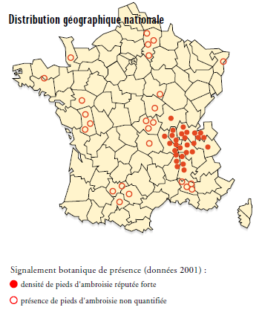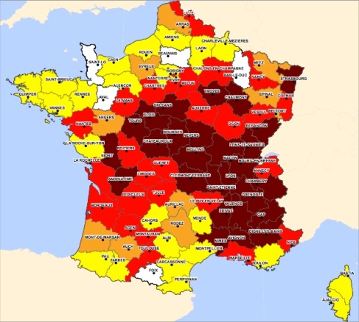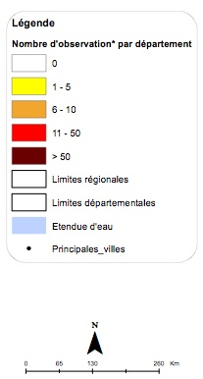
Figure 3: Ragweed Dispersion between 2001 (left) and 2013 (right) [4]
One of the ragweed proliferation factors is the increase in average temperatures; the fact that there have been fewer early frosts in autumn for several decades has optimized the plant's growth by increasing its vegetation period (+10 days in 30 years) and allowing it to colonize increasingly northern and mountainous areas. According to certain studies, the increased concentration of CO₂ in the atmosphere may actually contribute to pollen production. [5]
- Accounting for the proliferation of the tiger mosquito, a vector of tropical diseases (dengue fever, Zika virus, chikungunya fever), by implementing appropriate sanitation measures.
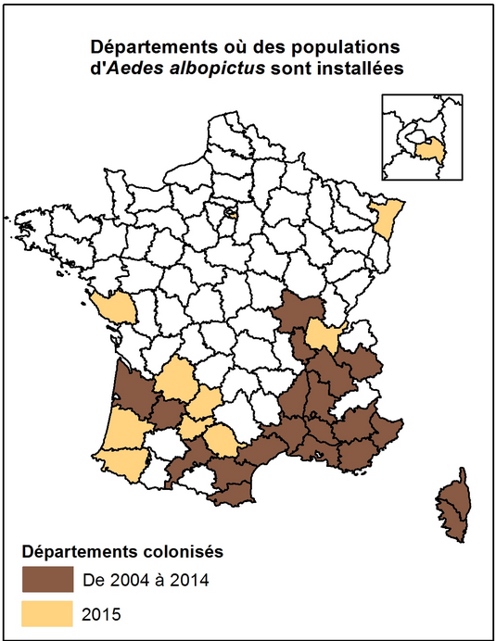
Figure 4: Tiger mosquito presence in mainland France (2015 data) [6]

- Assessment of the resistance of equipment (panels, extension arms, catenaries, etc.) and structures (civil engineering structures, porticos, etc.) to extreme weather events (storms, hurricanes, etc.), using established software: GERICI for the highway system and RESILIENCE for the railway system.
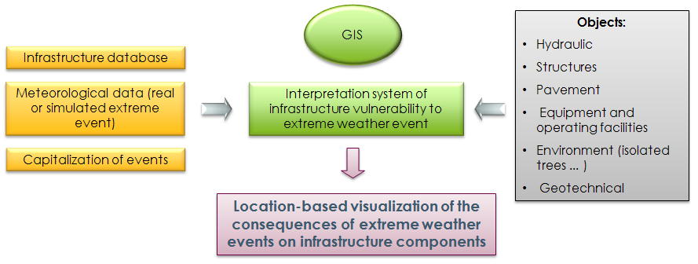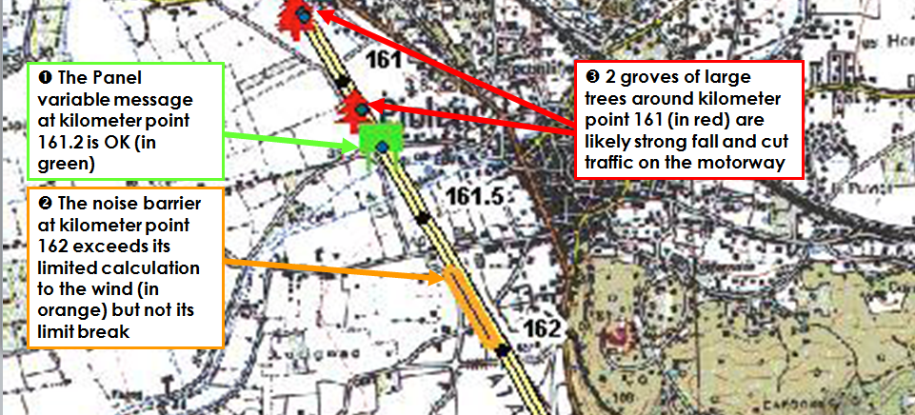
Figure 5: Logic diagram of how GERICI operates and examples of results for part of the highway system [7]

Conclusion
The discussed elements that consider climate change in environmental assessments in France serve as examples of lessons learned on this subject following changes to regulations. This subject still needs to be developed through further studies and also likely through the publication of methodology guides (which are currently unavailable).

Main references:
[1] Opportunity study for a Chateaurenard bypass © Egis for the Conseil Départemental des Bouches du Rhône [Bouches-du-Rhône departmental council].
[2] Greenhouse gas emission assessment for the LGV Sud-Europe Atlantique © Egis for LISEA/COSEA.
[3] Environmental assessment for project to expand highway A75 to 2 x 3 lanes between Clermont-Ferrand and Le Crest. © Egis for APRR—January 2017
[4] National map of ragweed presence / Fédération nationale des conservatoires botaniques nationaux [national federation of national botanical conservatories] (FCBN).
[5] Assemblée Nationale [national assembly]—Report—on behalf of the Commission du développement durable et de l’aménagement du territoire sur la proposition de loi visant à lutter contre l’ambroisie à feuilles d’armoise, l’ambroisie trifide et l’ambroisie à épis lisses [commission for sustainable development and area development on the bill to control common ragweed, giant ragweed, and Cuman ragweed] (No. 964), by Alain Moyne-Bressand, Deputy, November 27, 2013.
[6] http://www.signalement-moustique.fr/sinformer
[7] © EGIS / GERICI

Figures’s translation

Français / French | Anglais / English
Précipitations moyennes 2005-2015 (mm) | Average Precipitation 2005–2015 (mm)
janv. | Jan.
fév. | Feb.
mars | Mar.
avril | Apr.
mai | May
juin | June
juil. | July
août | Aug.
sept. | Sept.
oct. | Oct.
nov. | Nov.
déc. | Dec.
Précipitations moyennes 2005-2015 | Average Precipitation 2005–2015
Maintenance | Maintenance
Renouvellement | Renewal
Construction | Construction
Ouvrage en terre | Earthwork
Emprise | Right-of-way
Transport du personnel | Personnel transport
Équipement ferroviaire | Railway equipment
Ouvrage d'art | Civil engineering structure
Ouvrage hydraulique | Hydraulic structure
Chaussées et ouvrages annexes | Pavement and appurtenances
Superstructure ferroviaire | Railway superstructure
Distribution géographique nationale | National geographic distribution
Signalement botanique de présence (données 2001): | Signs of botanical life (2001 data):
densité de pieds d'ambroisie réputée forte | High density of ragweed plants
présence de pieds d'ambroisie non quantifiée | Presence of ragweed plants (unquantified)
Légende | Legend
Nombre d'observation* par département | Number of observations* per county
Limites régionales | Regional boundaries
Limites départementales | County boundaries
Étendue d'eau | Body of water
Principales villes | Major cities
Départements où des populations d'aedes albopictus sont installées | Counties with populations of Aedes albopictus
Départements colonisés | Colonized counties
De 2004 à 2014 | 2004 to 2014

Section 2 of Law 2009-967 for programming related to the implementation of the Grenelle Environment Forum.
Challenge: a certain environmental value must be recognized in the host environments in view of their state, how their state curves have changed over time (dynamic view of the environmental change), and the outlook with regard to current and future external pressures. This challenge is independent of the project.

